

# Team 24 – Sprint 1 Testing Document

Sakshi Choudhary, Giorgi Khmaladze, Nick Litman, Mihir Somani, Conley Utz

# User Story #01

**Test 1: Testing that a user can only register if they fill provide all the required details.**

Purpose: To meet the acceptance criteria, the user is created only if the user provides all the details: username, purdue email id, password, password confirmation.

Steps:

**Test 1.1 If the user does not put any input and press sign up button** 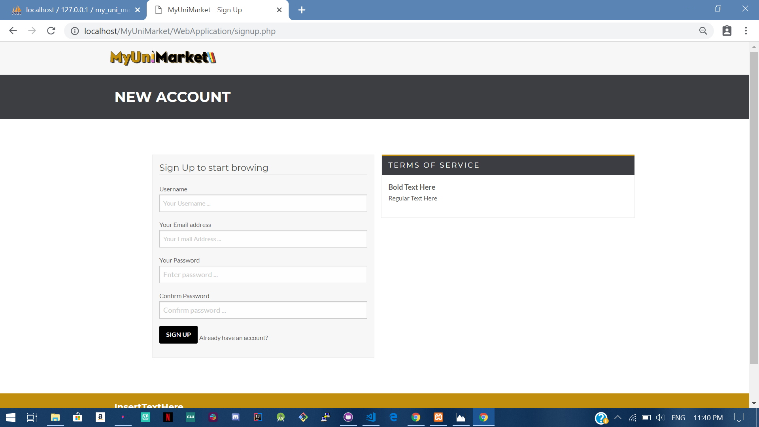

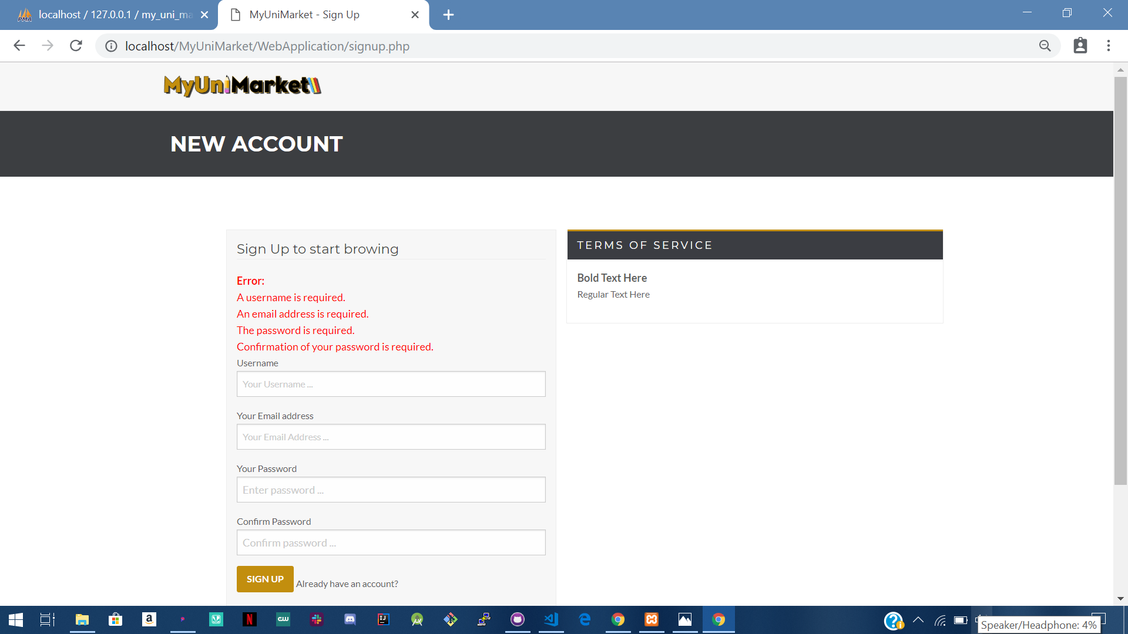

**Test 1.2 If the user just puts “Username”** 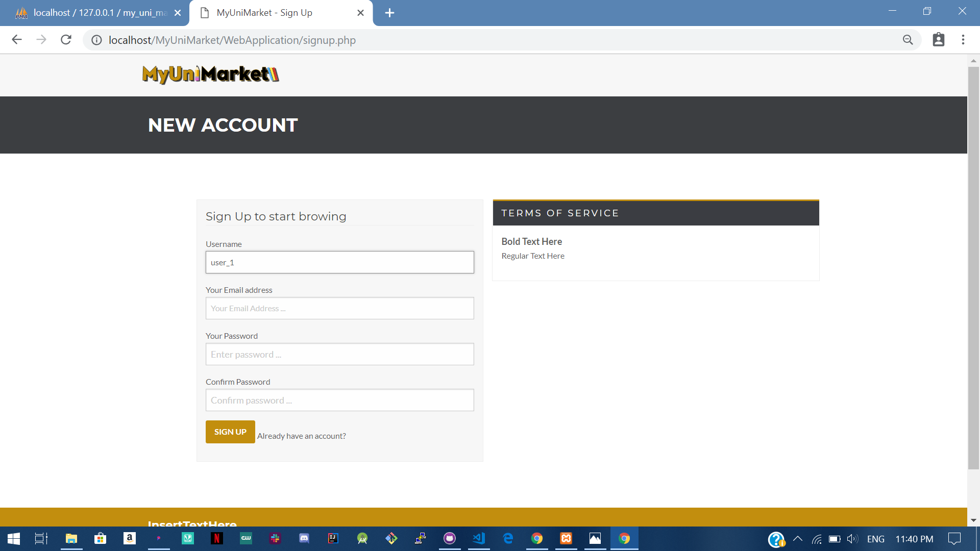

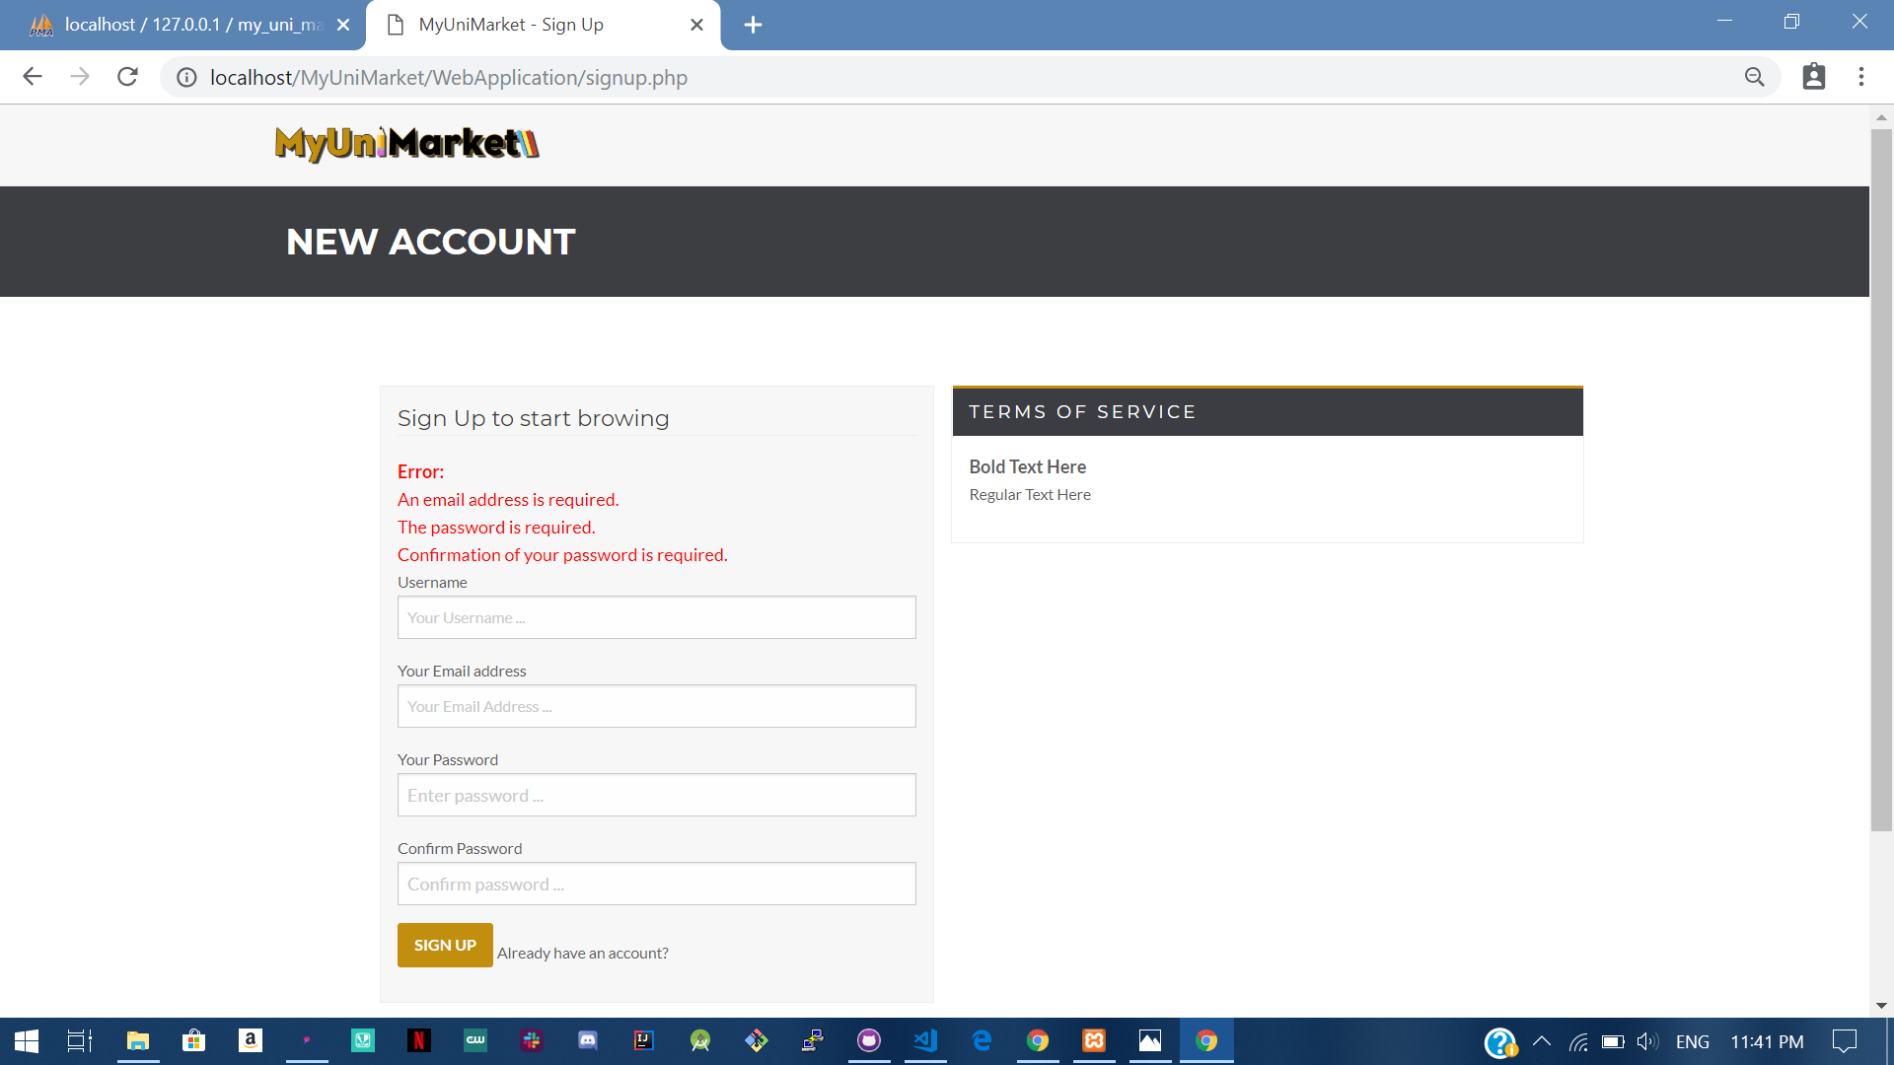

**Test 1.3 If the user just puts “Username” and “Email address”** 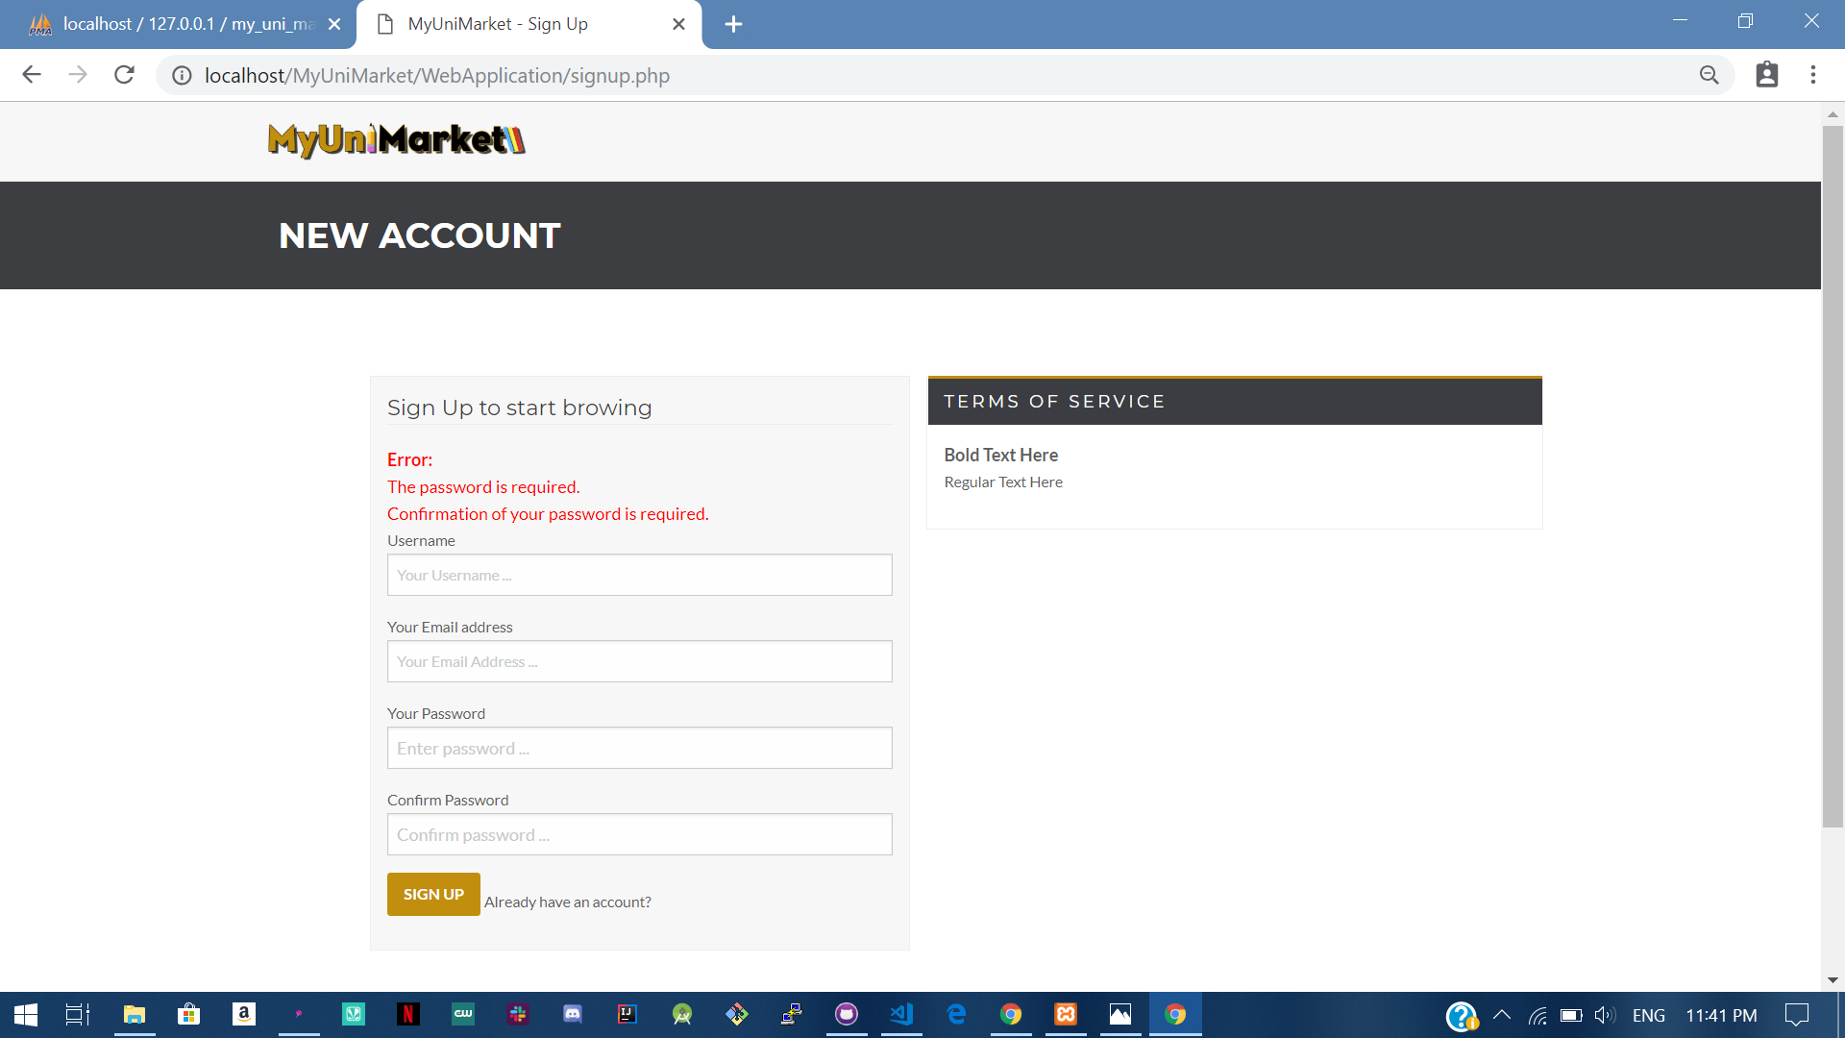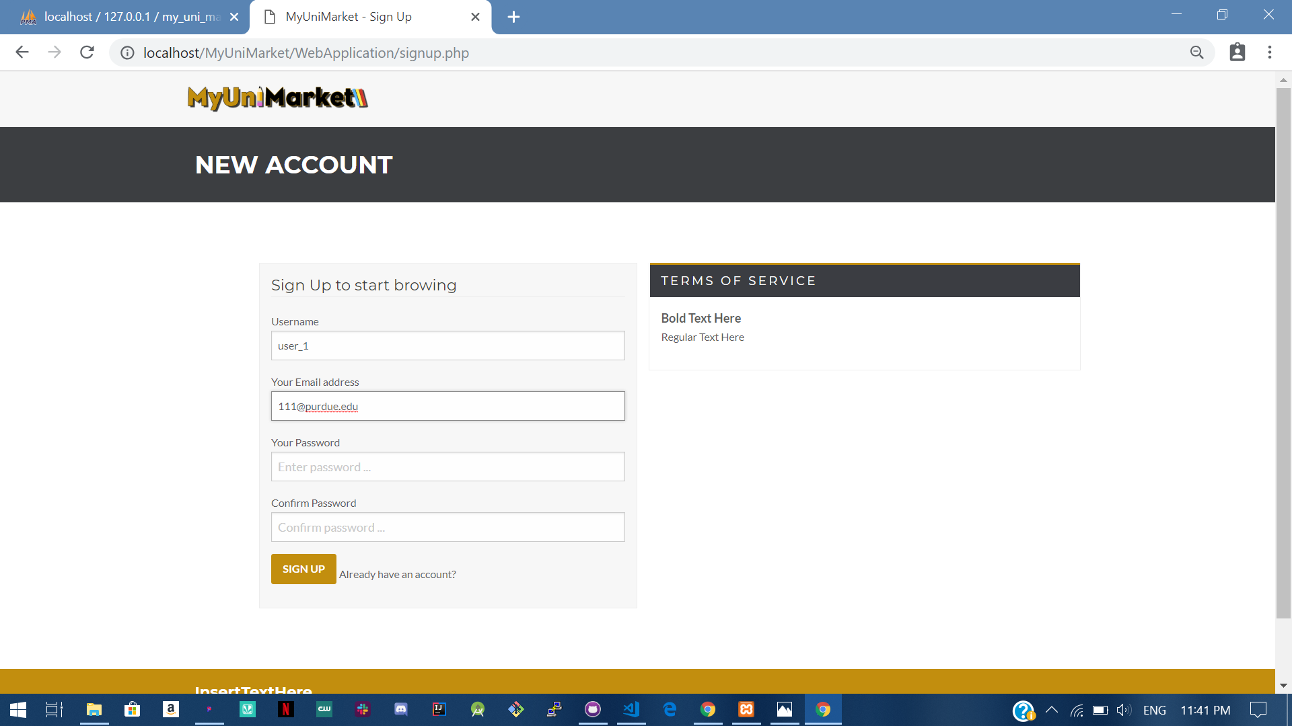

**Test 1.4 If the user just puts “Username” , “Email address” and “Password”** 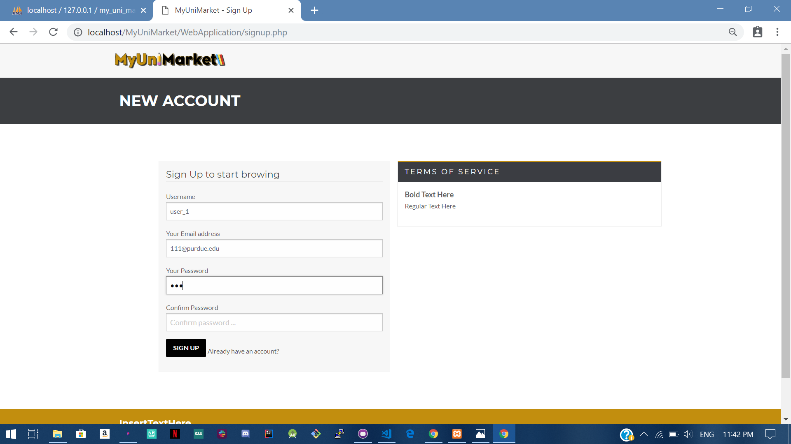

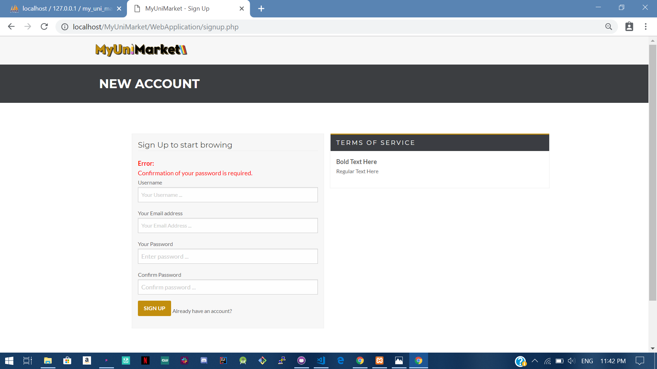

**Test 1.5 If the user puts all the required fields.**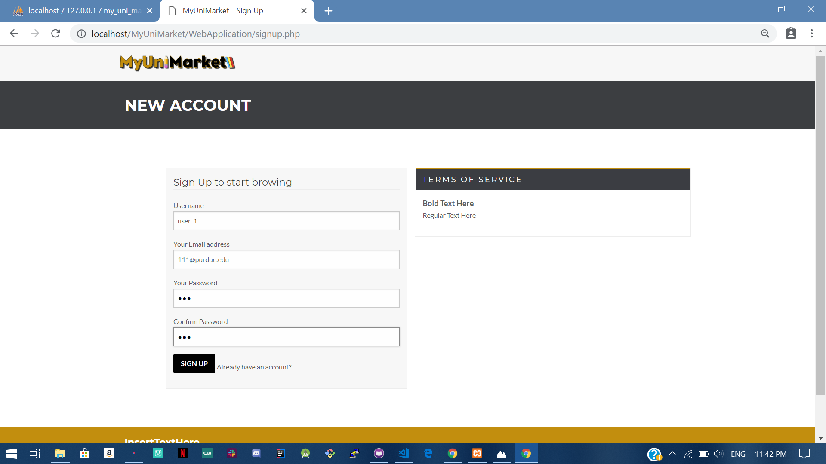

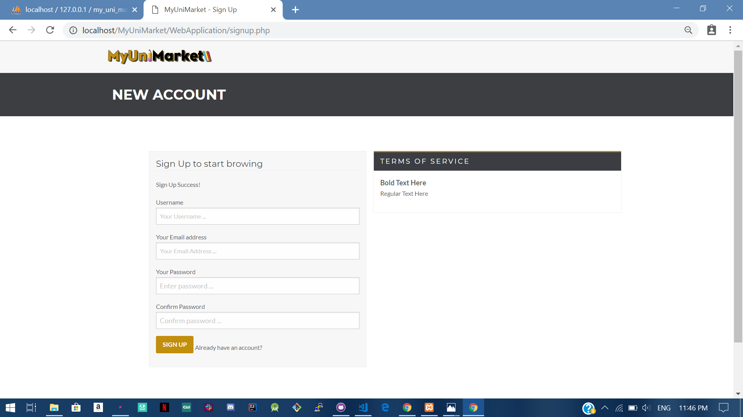

Expected: User is only created if the user provides all the user details .

Test Result: **PASSED**

**Test 2 Testing that a user can only register if the user provides an purdue.edu Email address** 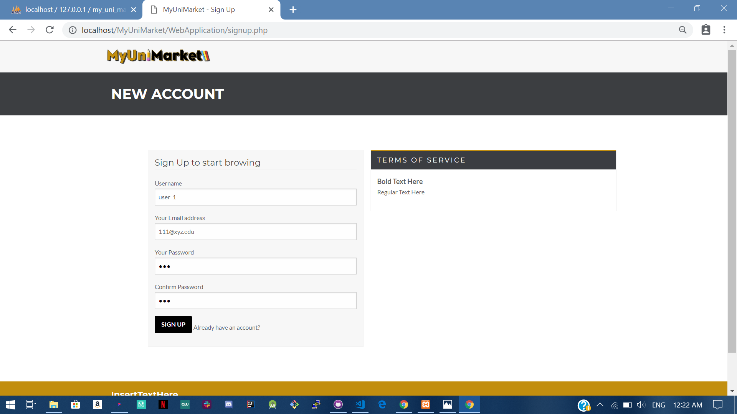

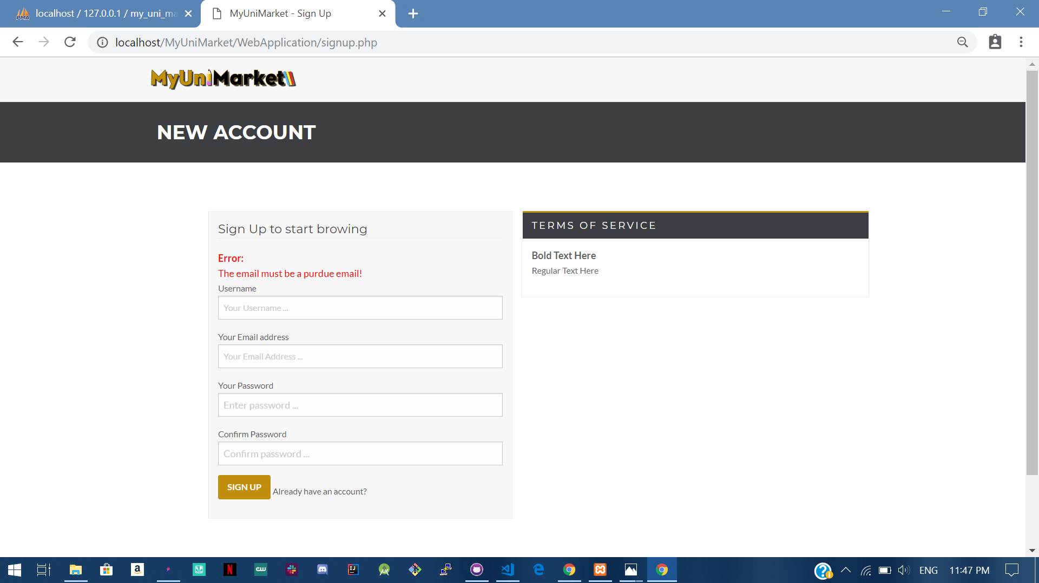

Expected: User cannot register without purdue email address.

Test Result: **PASSED**

**Test 3 Testing that a user is registered only after the user verifies their account.**

Step 1: Verification email is send to the user.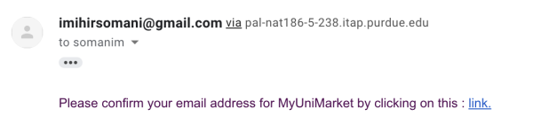

Step 2: If the user doesn’t verifies email and tries to sign in.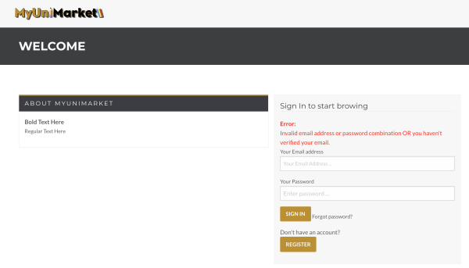

Step 3: If the user verifies email, confirmation is reflected in database and the user is registered.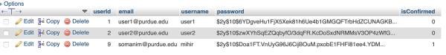

Expected: User can only sign in if they have verified their account.

Test Result: **PASSED**